# Topic:

Write a program to implement N-bit stop and wait protocol.

**Objective:**

Implementing N bit stop and wait protocol.

**Problem Statement:**

In this protocol, multiple frames can be sent by a sender at a time before receiving an acknowledgment from the receiver.

**Algorithm**

**Step 1** – Here, sliding window of size is N.

**Step 2** −After receiving a frame from the sender, the receiver sends an acknowledgment (ACK), which includes the number of the next frame it expects to receive.

**Step 3** – If N value is 3 then we can see the sender first sends 1, 2, 3 to the receiver, then after receiving an acknowledgment for received 1 and sending 4 from the receiver, the sender again sends 4. It works similarly for sending 5, 6 and so on to N.

**Step 4** − But this process can face errors sometimes. Considering the receiver faces some error while receiving a frame, the receiver doesn't send an ACK back. For these situations, the sender maintains a timeout for receiving an ACK for every frame.

**Step 5** − If it exceeds the time, then the sender resends the frame and adds it to the receiver if it's not already present there otherwise ignores it.

**Step 6** − Another error is faced when an ACK is sent by the receiver and lost before receiving it by the sender. A similar use of timeout is applied for this error handling too.

**Code:**

#include<stdio.h>

int main()

{

int w,i,f,frames[50];

printf("Enter window size: ");

scanf("%d",&w);

printf("\nEnter number of frames to transmit: ");

scanf("%d",&f);

printf("\nEnter %d frames: ",f);

for(i=1;i<=f;i++)

scanf("%d",&frames[i]);

printf("\nWith sliding window protocol the frames will be sent in the following manner (assuming no corruption of frames)\n\n");

printf("Here window size is %d so, at each stage only %d frame is send and wait until Acknowledgement is sent by the receiver. \n\n",w,w);

for(i=1;i<=f;i++)

{

if(i%w==0)

{

printf("Frame no. %d\n",frames[i]);

printf("Acknowledgement is received\n\n");

}

else

printf("%d ",frames[i]);

}

if(f%w!=0)

printf("\nAcknowledgement of above frames sent is received by sender\n");

return 0;

}

**Output:**

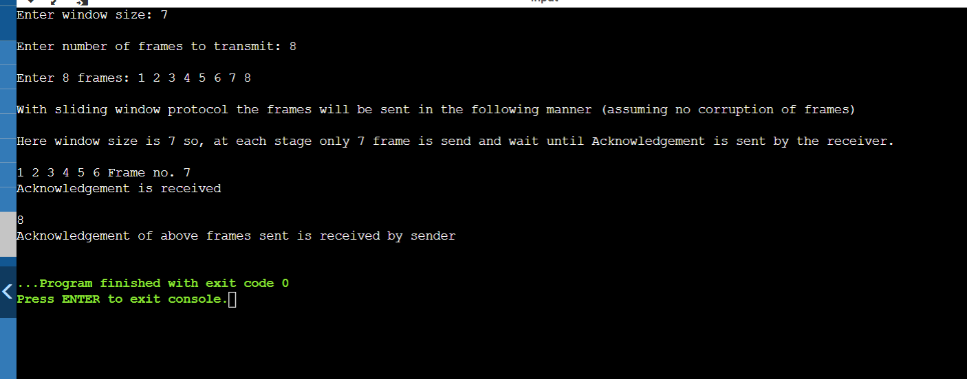

Here, window size is 7 and number of frames are 8. Enter the frames, with sliding window protocol the frames are transmit in the following way. Here, window size is 7 so, at each stage 7 frames are sent and wait until ack is sent by receiver. Here, number of frames are 8 so at first, 7 frames are transmitted and ack is received and frame 8 is send then ack of 1 to 6 frames are sent is received by the sender.

**Problems Faced:**

In this experiment, I didn’t face any problem. It is quite easy topic.

**Conclusion:**

With the help of this assignment, I understood the concept of N-bit stop and wait protocol.